Introduction to Grouping

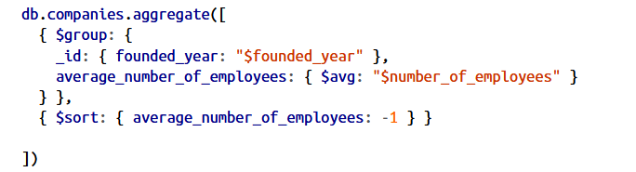

Here, we’re using a group stage to aggregate together all companies based on the year they were founded, then calculate the average number of employees for each year.

{ "_id" : { "founded_year" : 1847 }, "average_number_of_employees" : 405000 }
{ "_id" : { "founded_year" : 1896 }, "average_number_of_employees" : 388000 }
{ "_id" : { "founded_year" : 1933 }, "average_number_of_employees" : 320000 }
{ "_id" : { "founded_year" : 1915 }, "average_number_of_employees" : 186000 }
{ "_id" : { "founded_year" : 1903 }, "average_number_of_employees" : 171000 }
{ "_id" : { "founded_year" : 1865 }, "average_number_of_employees" : 125000 }
{ "_id" : { "founded_year" : 1921 }, "average_number_of_employees" : 107000 }
{ "_id" : { "founded_year" : 1835 }, "average_number_of_employees" : 100000 }

The group stage will take every document that has the same value for "founded_year" and treat them as a single group

